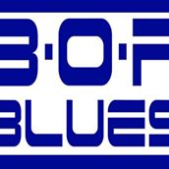
BOP Blues Club Newsletter January 2020
Welcome to the first BOP Blues Club Newsletter for 2020, we hope you all had a safe and Happy Christmas and New Year and that you are ready for an exciting year of live music that the club has in store for you all including the Rotorua Blues Festival which is back on the calendar for later in the year, but more on that shortly.
The first jam night for 2020 was held on Wednesday 8th January at the Rotorua Citizens Club with around 100 people in attendance which created a fantastic atmosphere on a warm summer night which saw some equally hot talent take to the stage with a great mix of tunes played by all who participated.
The night was kicked off by the “House Band”, our well-known Ali Morgan on lead guitar, our equally well-known Rob Gillies on bass guitar and Ian Hunia on drums, 3 cool tracks ranging from B.B King to Stevie Ray Vaughan, with all members singing a song each…great stuff
Kararina was next to show her solo talents on her electric acoustic guitar with Etta James’ “Summertime” and Leonard Cohen’s “Hallelujah”.
The very, very talented musician Lloyd Akroyd was next to take the stage, singing and playing his electric acoustic guitar and performed his own original song “A Little Story” followed by a great rendition of Bill Withers “Ain’t no Sunshine “and finally “The beauty of who you are” by Marc Broussard. Very lucky to have him join us and we look forward to seeing him again in the future.
A unique act going by the name of “Jamminukes” comprising three Ukulele players, Gary, Mary and Esther, was a refreshing contrast to the usual format, playing songs by Rod Stewart, Eric Clapton, and believe it or not a song by the old English comedy duo Morcombe and Wise “Bring me Sunshine”. Great music comes in all shapes and sizes.
Travelling all the way from Whakatane, our latest Club Member Reuben Paraha was joined by Anarah on vocals with a modern version of the late great Johnny Otis track “Willy and the Hand Jive” done in the George Thorogood style, and then got the crowd’s feet really tapping by finishing with a Christine Aguilera rendition of the Etta James song “Somethings got a hold on me”.
Our very own Nikau Chater with “The Natives” played 3 fantastic numbers including “People get Ready” by Curtis Mayfield before been joined by guitarist Rob Powley’s daughter Alayna Powley on stage to perform “I’ve never loved someone (The way I loved you)” by Aretha Franklin and the classic “Knockin’ on Heavens Door” by Bob Dylan. Great to see such fabulous young talent on stage…
“Biddy with Mojo” Brigitte Kimber also made the trip from out of town travelling all the way from Hamilton to BELT out some very energetic tunes including “Put on your tight pants Baby” by Ike and Tina Turner, “Pleasantly Blue” by the Four Non-Blondes and “Two Fisted Mama” by Katie Webster. Brigitte was supported by Committee members Terry, Deb, Paul. H and “Lady” Di on “Toys” including the talents of Grant from Boston USA on rhythm guitar, who was also lucky enough (and very happy) to win the Club Raffle on the night
Our very own, super talented, Bobby Howard and the band STAVE then graced the stage and performed a great rendition of “Happy Anniversary” by Little River Band, and “Black Velvet by Allanah Miles before being joined by another surprise of the night that was a young singer by the name of Matahiapo Maxwell who collaborated with STAVE to sing “At Last” by Etta James and was backed by Rob Gillies on bass, Ian Hunia on drums and Ali Morgan on guitar.
The last band for the night was “Theory 89” made up of Terry & Deb Oldham, “Lady” Di, Carolyn Scherger on drums and young Ben Todd on Guitar. Playing “Long Cool Women in a Black Dress” by CCR, “Brown Sugar” by the Rolling Stones, and Jimi Hendrix tune “Hey Joe”.
And to add, thank you to all who bought tickets in our Club raffle on the night with proceeds being donated to the World Wildlife Fund to help with animals affected by the devastating bushfires in Australia, your generosity was very much appreciated.
So as you can see by this list of performances that it is always well worth coming down and supporting the club on these jam night as you never know what lays in store, and for the cost of only $5.00 for non-members and an annual subscription of $40.00, it is the best money you will spend to see some truly talented musicians take to the stage in a relaxed and friendly environment.
The BOP Blues Club is in the process of organizing the Rotorua Blues Festival for Queens Birthday Weekend, the 29th,30th & 31st May 2020 and we are very pleased and excited to announce our headline acts for the Festival are super talented NZ Artist Merenia Gillies and her Band from Sydney, Kiwi Blues Legend Darren Watson, and well known Tauranga Band “Hybrid Blues” who will round out a stellar night at the Citizens Club on Sunday 31st May…Tickets will available soon on our website. Please go to the BOP Blues Web Page www.bopblues.com for further details.

The next jam night is not far away now being Wednesday the 5th February from 7:30pm at the Rotorua Citizens Club and with the Waitangi Day public holiday the following day, there will be no need to rush off early. There are full bar facilities available and a very reasonably priced restaurant for you to enjoy also…. We look forward to seeing you there for another great night of live music and entertainment.
Regards,
Paul Verney.
“The Blues Buster”
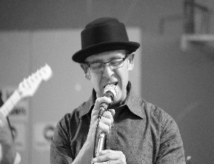

Some Pic’s from the Night
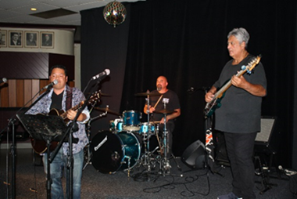
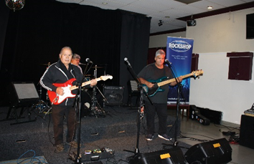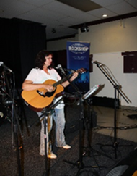
House Band Kararina Lloyd Akroyd 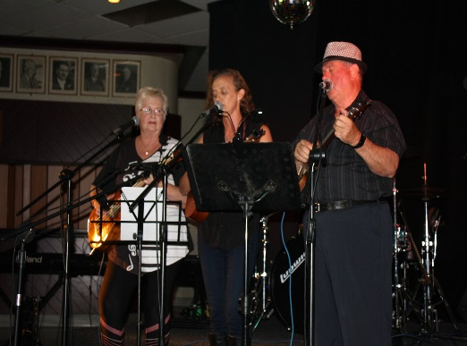 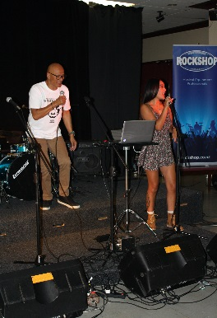 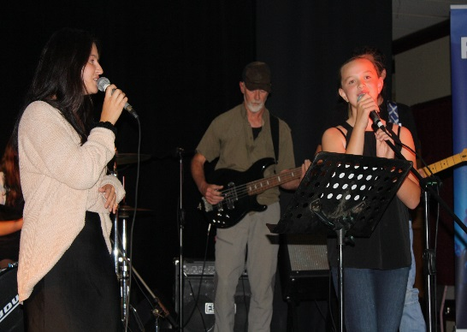
Jamminukes Reuben & Anarah Alayna & Nikau
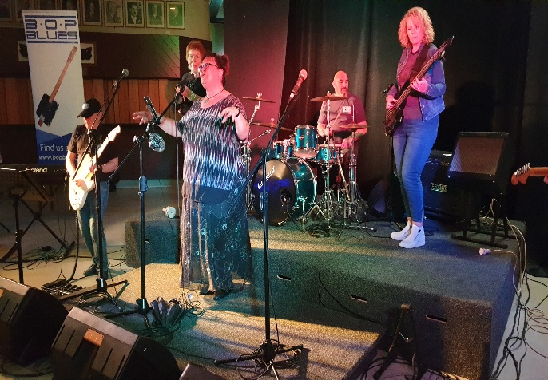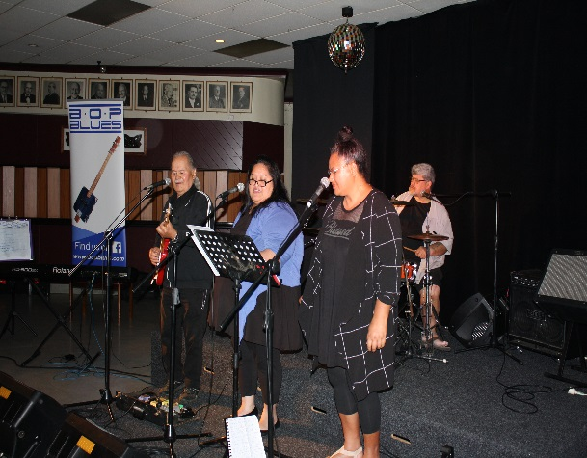
“Biddy with Mojo” Bobby Howard with “Stave”
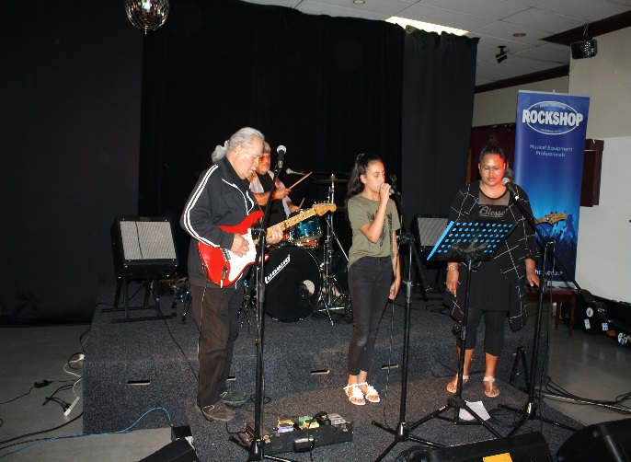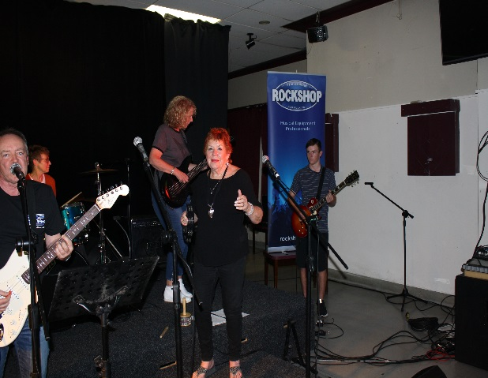
Matahiapo Maxwell Theory 89”

See you for our next Jam night on the 5th Feb from 7.30 @ our great venue the Rotorua Citizen Club, 1146 Rangiuru Street
Proudly Rotorua

