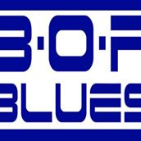
BOP Blues Club Newsletter February 2020
Wow, wow wow…what a fabulous night we had for our 2nd Jam night for 2020 held at the Rotorua Citizens Club on Wednesday the 5th of February with a great mix of musicians, both local and travelling from out of town and a lovely big crowd of around 100 or more who were there to hear the music and join in the fun on a warm summers evening with a public holiday to follow.
The night was kicked off by guitarist and singer Tamati Cassidy who had travelled from Taupo and was joined on stage by keyboardist Mike Bathe, also from Taupo, and a late inclusion from Rotorua local Chris Cubis on Harmonica, they all played a couple of fantastic tunes including the well-known Elvis Presley song “Hound Dog” done with a real blues flavor, great stuff.
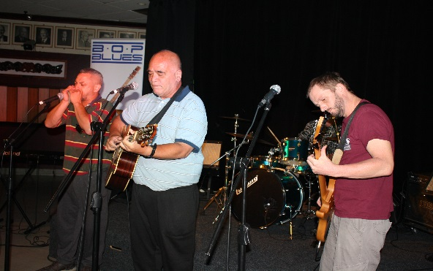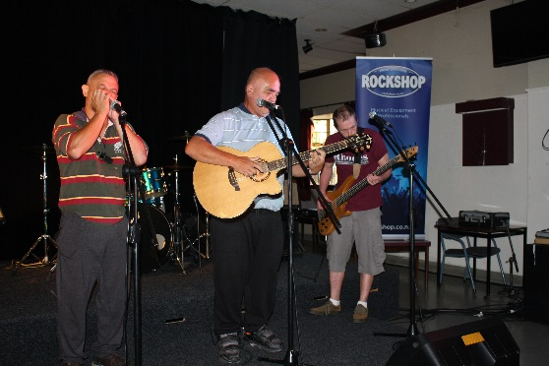
Rotorua’s very own “Blues Busters”, Lead guitarist Terry Oldham, Bassist Deb Oldham, Rhythm/Lead Guitar player Ben Todd, Drummer Carolyn Scherger, Jim Park on Keyboards, “Lady” Di Riddel on “toys” and myself, Paul Verney on vocals, were next to take to the stage and started with a tune by the late great B.B King “Why I sing the Blues” followed by a cruisy number by Dire Straits called “Six Blade Knife” and then ramped it up to finish with The Black Crowes version of “Hard to Handle” which really had the crowd starting to tap their feet.
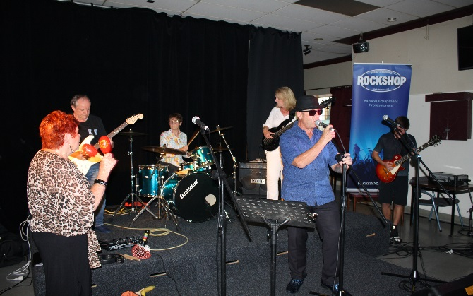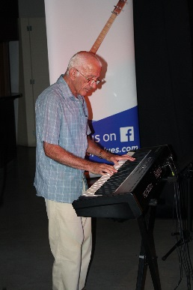
Some of the “Blues Busters” then stayed on stage to support Brigitte “Biddy with Mojo” Kimber who had come all the way from Hamilton with her powerhouse vocals and sang “Sweet Home Chicago” as well as a great rendition of Otis Redding’s “Knock on Wood”, absolutely brilliant. It was an even better night for Brigitte when her ticket for the musician’s raffle was the winning one and I don’t think she will have any trouble spending her voucher kindly donated by The Rock Shop.
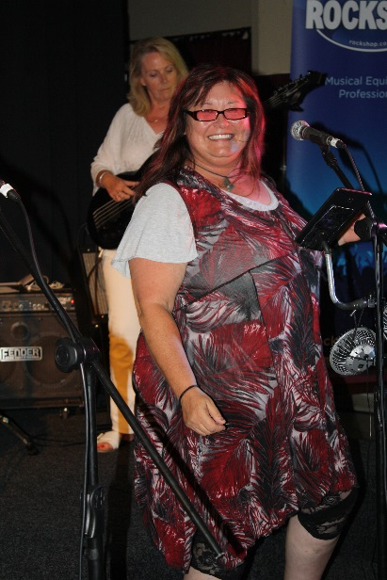

We were also very lucky to have the superbly talented Fiona Cosgrove who had come across from Whakatane to join us and she took to the stage with the equally talented Maciek Hrybowicz on guitar and sang a fantastic version of the Joss Stone song “Dirty Man” followed by “Ain’t got nothing but the Blues” by Robben Ford and finally “Voodoo Woman” by the legendary Blues Woman Koko Taylor where they were also joined on stage by Bass Player Jimmy Murray.

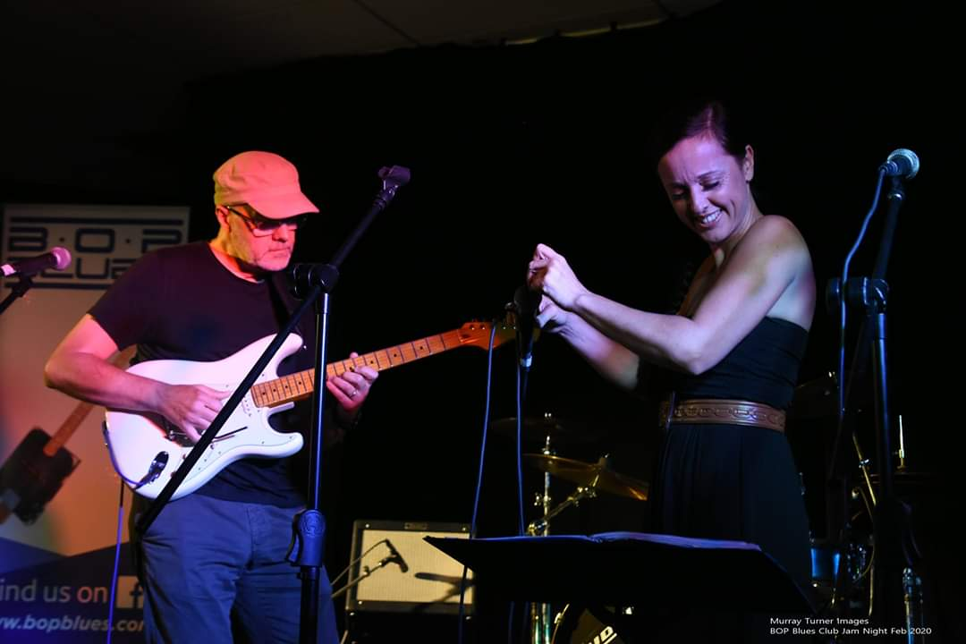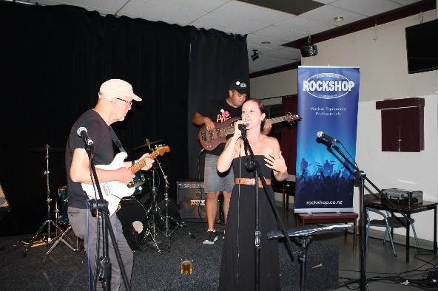

Another “Out of towner” that graced us with her presence was Dionne Bidois who had made her way from Matamata and was joined on stage by Mike Bathe on keyboards and Tamati Cassidy on guitar, for the first two songs which were “Old Love” by Eric Clapton, and “Just the two of Us” by Grover Washington Jr, ending up with a great rendition of “Unchain my Heart“ next thing you know the stage now has six people on it including Noel “The Pres” Lamberton on Drums, a visitor Carolyne from London on backing vocals and Di Riddel on percussion.
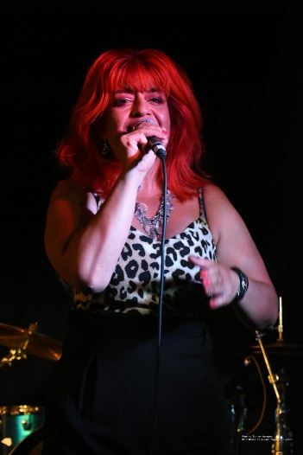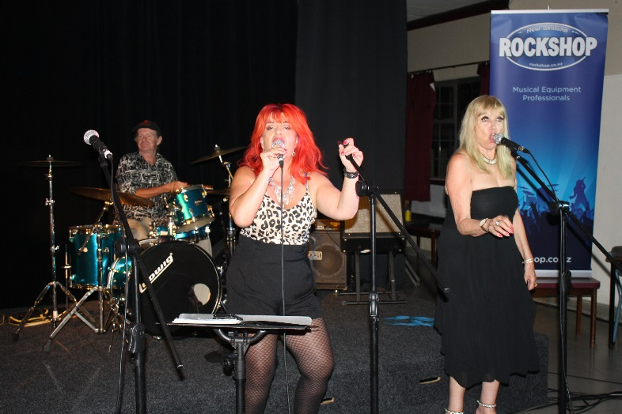

That’s what I love about Jam Nights, spontaneity…

Another absolute highlight on the night was when New Caledonian (now living in Rotorua) Claudine did a solo on keyboards and sang a Carole King song “Smackwater Jack” with effortless ease followed by a very “Edith Piaff style” song “Drole de Vie” by Veronique Sanson sung completely in French, something unique indeed.
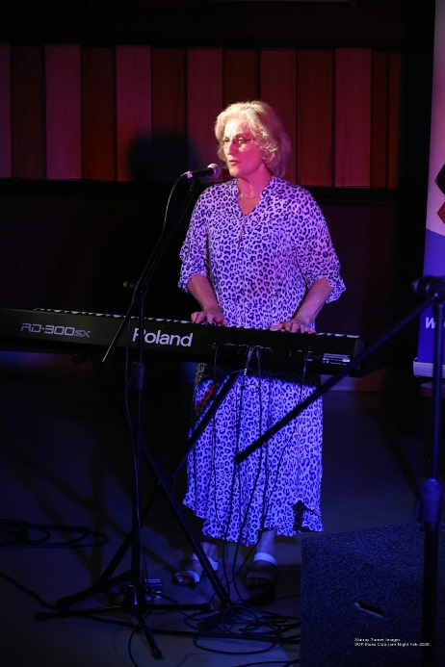

One of Claudine’s friends Stephanie Morando was also very happy she came to our club night to support Claudine as she was the lucky winner of the Gift Hamper Raffle. Well done.!
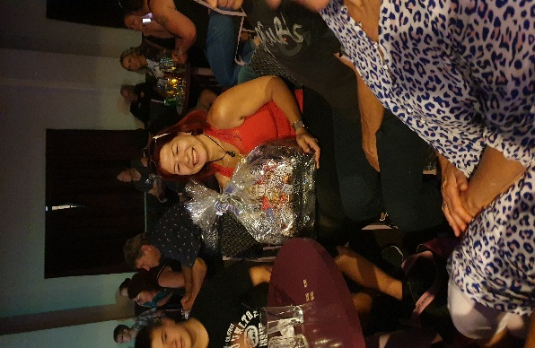

Keith and Lindsay were next up and also had the crowd well entertained with” Green Door” by Shakin’ Stevens and “Ain’t that a Shame” by Fats Domino done with such style that you could not help but be pleased you were amongst the crowd…happy days.
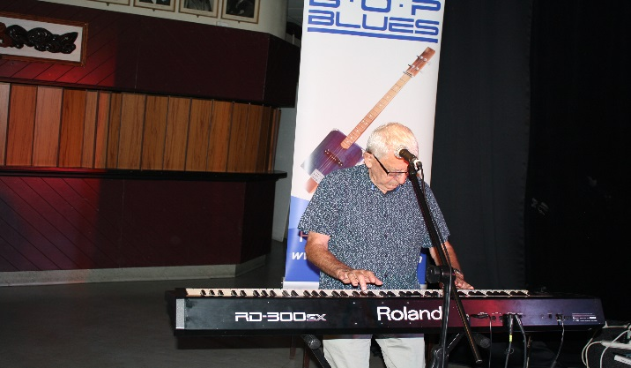
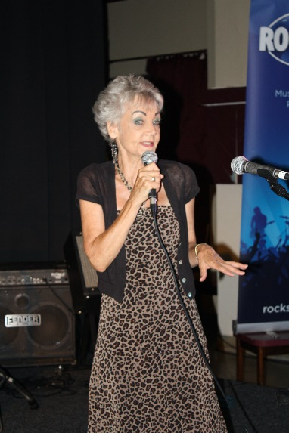
As if that all wasn’t entertaining enough we then had the absolute musical legend Brownie Brown from Tauranga blow everyone away joined by Tamati Cassidy (now on Bass guitar) Mike Bathe on keyboards, Chris Cubis on Harmonica and Noel Lamberton on Drums with some brilliant tunes including “Down to the Doctor” by Dr Feelgood, an original of Brownies called “Afraid of Thunder” and a cracking rendition of “Roadhouse Blues” by The Doors. The dance floor now had a few people up “shakin’ it” by this stage which was just great to see and be a part of.
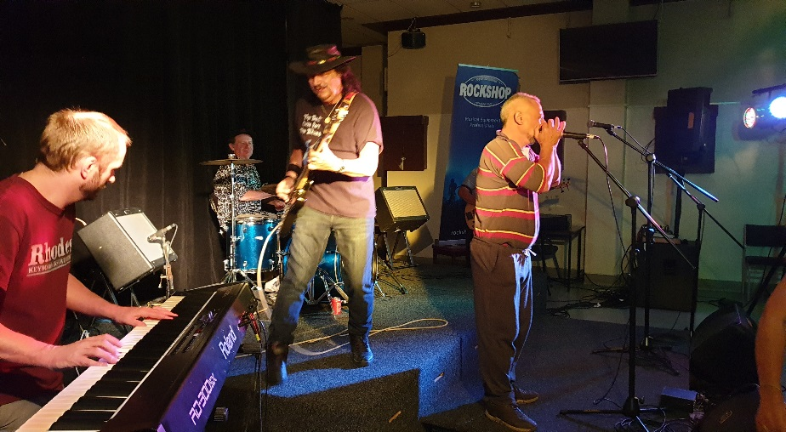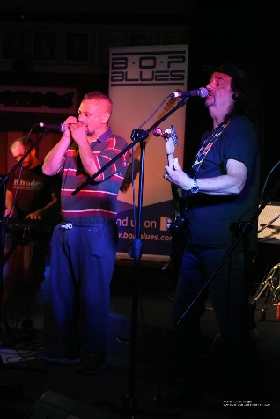

Local girl Janine from “Theory 89” also got up and sang a couple of songs, “Dreams” by Fleetwood Mac, and the Aretha Franklin tune “Chain of Fools” and was gratefully received by the eager crowd.

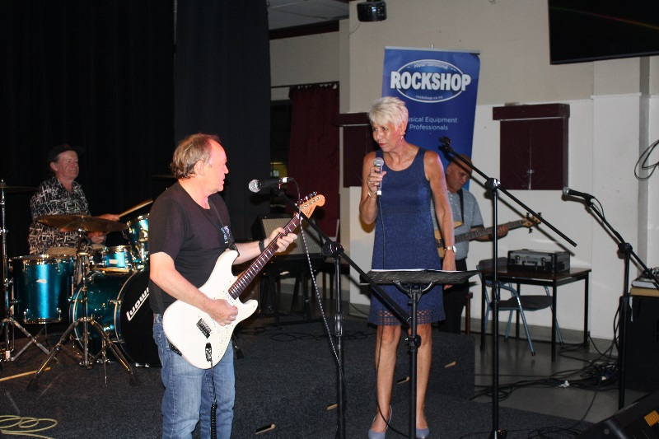

Lloyd Akroyd graced our jam night again and was joined by fellow local musicians Trojan John on vocals and guitar and J.T. playing the drums and performed two original songs “Life’s too Short” and “Always” which were just awesome followed by the very well-known Eric Clapton song “Wonderful Tonight”. A real pleasure to have such accomplished musicians in the house and really hope these guys continue to come and join us for our club nights in the future.
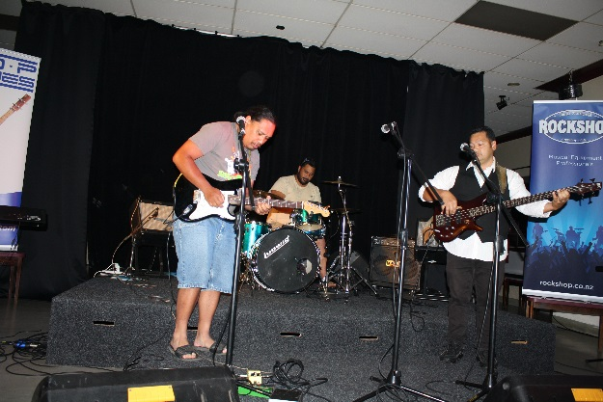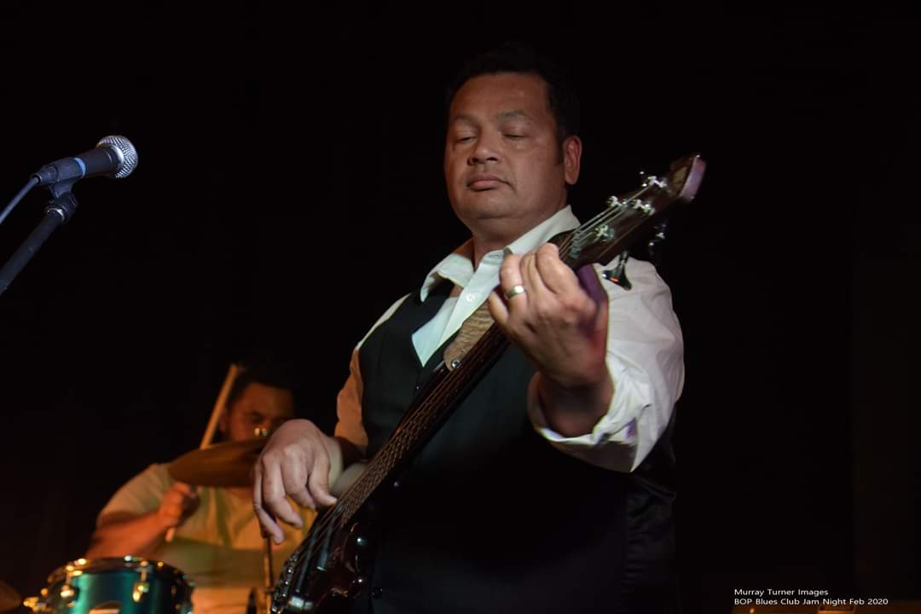

The last “band” for the night we called “Wing It” and was made of some young musicians, Tayla Paul on Bass guitar and Riley on drums, as well as the very experienced Terry Oldham on guitar, “Lady” Di on percussion and yours truly providing vocals. I had been asked earlier on in the evening by Tayla and Riley if I would sing a couple of songs with them and as BOP Blues is all about supporting young musician’s I did not hesitate to help them out. Such talented young people.

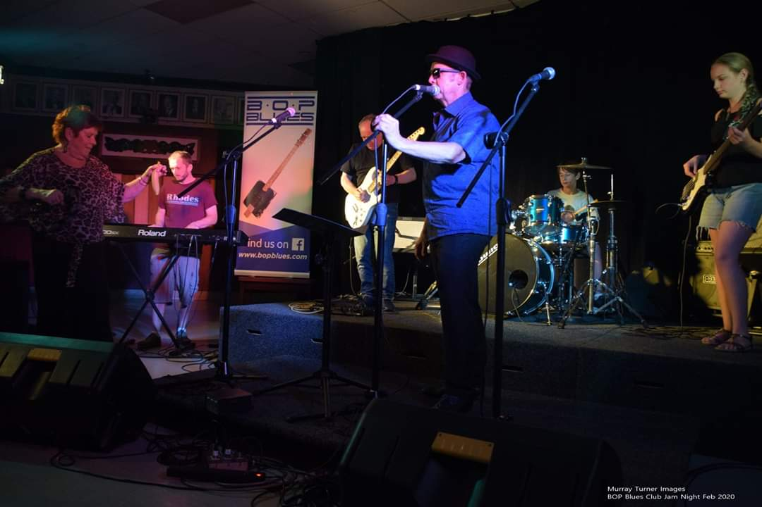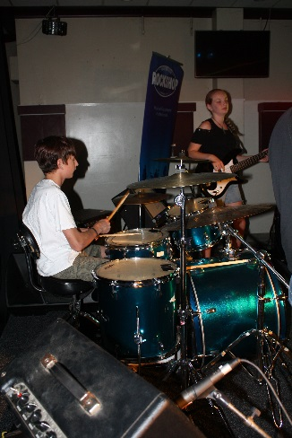

So as you can see by this list of performances that it is always well worth coming down and supporting the club on these jam nights as you never know what lays in store, and for the cost of only $5.00 for non-members and an annual subscription of $40.00, it is the best money you will spend to see some truly talented musicians take to the stage in a relaxed and friendly environment.
The BOP Blues Club is in the process of organizing the Rotorua Blues Festival for Queens Birthday Weekend, the 29th,30th & 31st May 2020 and we are very pleased and excited to announce our headline acts for the Festival are super talented NZ Artist Merenia Gillies and her Band from Sydney, Kiwi Blues Legend Darren Watson, and well known Tauranga Band “Hybrid Blues” who will round out a stellar night at the Citizens Club on Sunday 31st May…Tickets will available soon on our website. Please go to the BOP Blues Web Page www.bopblues.com for further details.
The next jam night is on Wednesday the 4th of March 2020 from 7:30pm at the Rotorua Citizens Club. There are full bar facilities available and a very reasonably priced restaurant for you to enjoy also…. We look forward to seeing you there for another great night of live music and entertainment.
Regards,
Paul Verney.
“The Blues Buster”
